

ONEERP Mobility - PFD

TEMPLATE CHANGE CONTROL
Version | Author | Reviewed By | Approved By | Effective Date | Change History
1.0 | Mahisha Varshini C | Saikiran Malleli | Mohan Narasimhan | October 15, 2024 | Initial Issue

DOCUMENT DETAILS
Document Name | Document Type | Practice Area/Business Unit | Confidentiality | Distributed To
ONEERP Mobility - PFD | Product Functionality Document | ERP Business Unit | Public-Restricted | ERP BU & Clients

TABLE OF CONTENTS

Introduction 4
Supported Versions 4
Supported Languages 4
Login 4
Home Page 4
User Configuration 6
Management Dashboard 7
Approval Dashboard 7
Sales Analysis 8
Mobility Sales 8
Sales Quote 8
Sales Order 9
Delivery Note 10
Sales Invoice 11
Support for KSA e-invoicing 12
Sales Return 12
Support for KSA e-invoicing 13
Customer Status 14
Price List Update 14
Mobility Inventory 15
Location Transfer Out 15
Location Transfer In 16
Stock Status 16
Stock Take Sheet 17
Mobility Procurement 18
GRN with PO 18
Direct GRN 18
GRN Cum Costing 19
Mobility WMS 20
Putaway 20
Picking 21
Internal Transfer 22
Cycle Count 23
Positionwise Query 24
Itemwise Query 25
Configurations to be considered 25
About Azentio Software 27

Introduction
ONEERP Mobility applications allow companies to benefit from improved quality of service, deeper business relationships and more accurate data capture – not to mention access to important data from any location at any time. ONEERP Mobility provides an entirely new dimension to your business processes by enabling you to access ONEERP Enterprise Suite data on any mobile device. It directly leads you to greater productivity, better customer service and improved data capturing.

Supported Versions
- Android above 11
- iOS above 11

Supported Languages
- English

Login
- Install the APK file
- Enter the company URL by clicking on settings icon(placed at top right of the screen) in Login page
- Enter the correct credentials to access specific account details

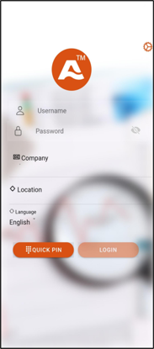
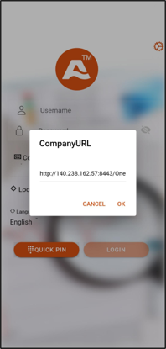

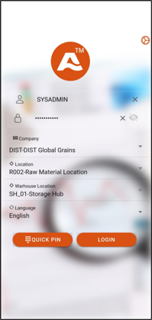
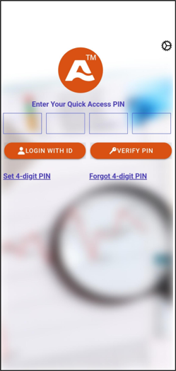

Home Page

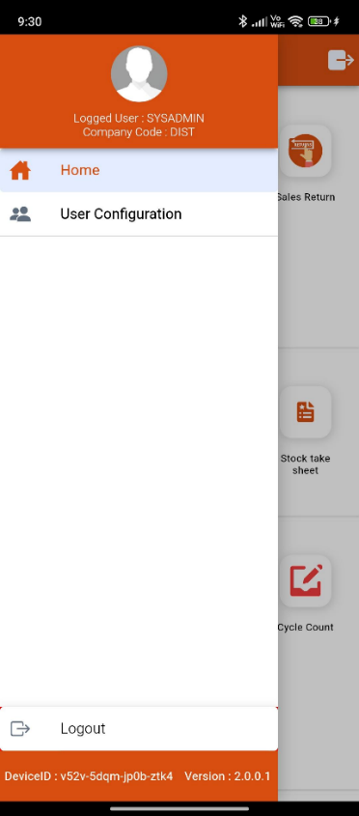
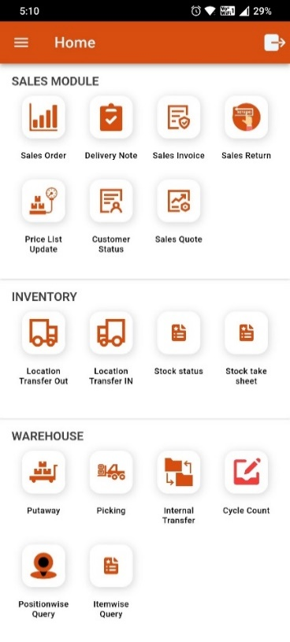
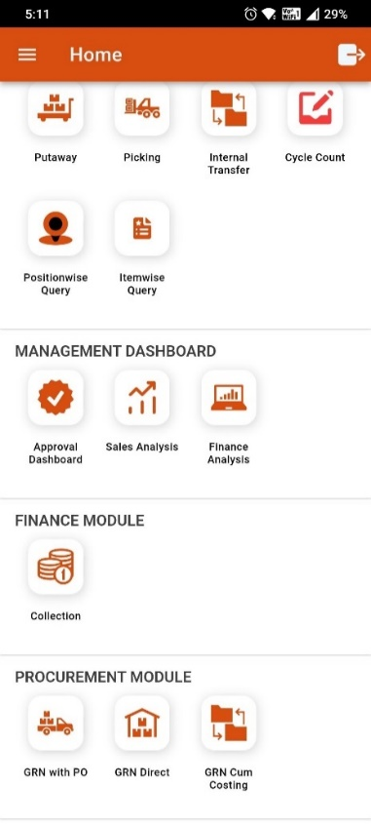

User Configuration
User Configuration/Management refers to the process of managing and organizing user accounts and permissions within a system, ensuring appropriate access and security for users.

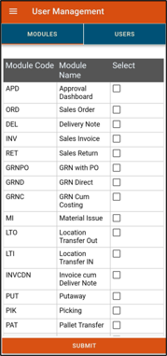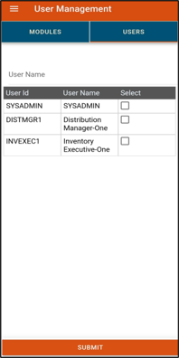

Management Dashboard

Approval Dashboard
An approval dashboard is a visual interface that displays pending approvals, allowing users to review, manage, and track requests for authorization in real time.

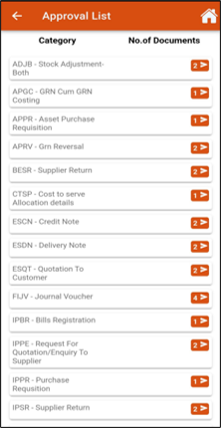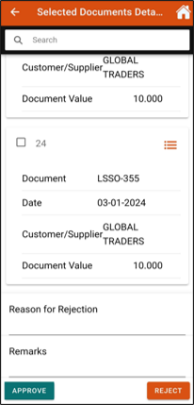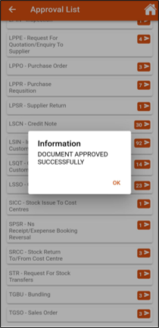

Sales Analysis
Sales analysis is the process of examining sales data to identify trends, patterns, and insights, helping businesses make informed decisions to optimize performance and drive revenue growth.

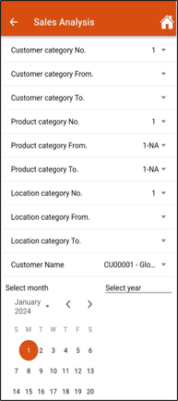
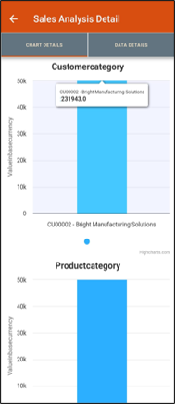
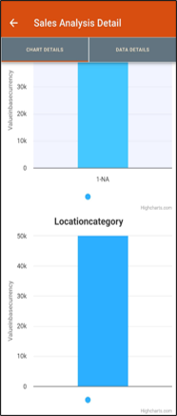
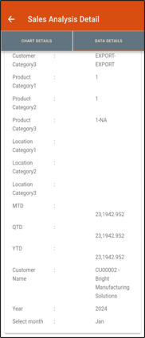

Mobility Sales

Sales Quote
A sales quote is a formal document provided to a potential customer that outlines the proposed prices, terms, and conditions for specific products or services, serving as a basis for negotiation and agreement.
Features available as part of this are listed below.
- Direct creation
- Scan Item
- LOV for selecting Customer & Item
- Item line level tax & discount
- Document Approval/Pushback option
- Document download option

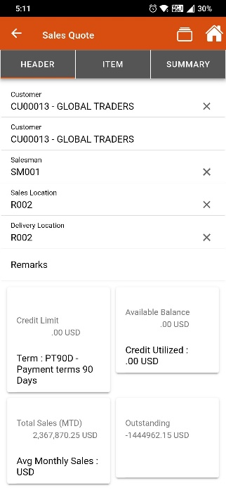
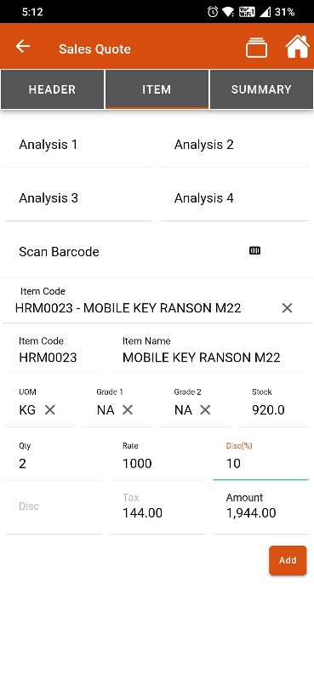
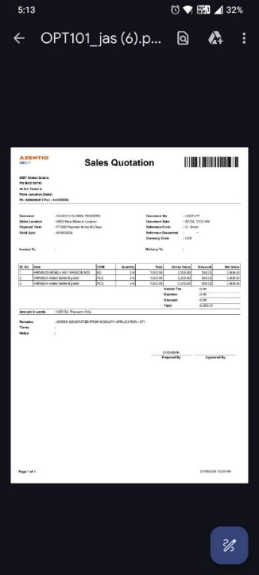
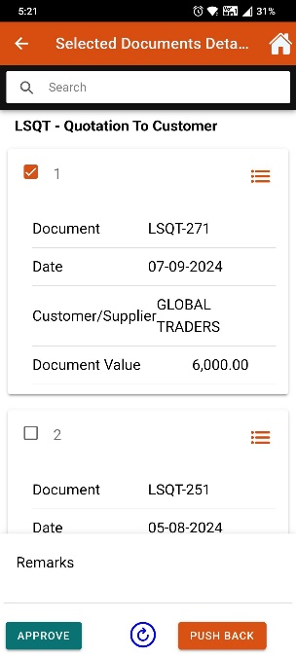

Sales Order
A sales order is a document confirming a customer's request to purchase goods or services, detailing the items, quantities, prices, and terms of the sale.
Features available as part of this are listed below.
- Can be created as Direct/with reference to Sales Quote
- Scan Sales Quote feature to fetch details in Sales Order
- Scan Item
- LOV for selecting Customer & Item
- Item line level tax & discount
- Document Approval/Pushback option
- Document download option

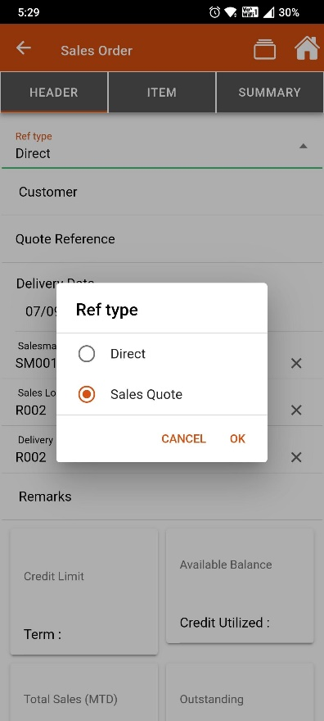
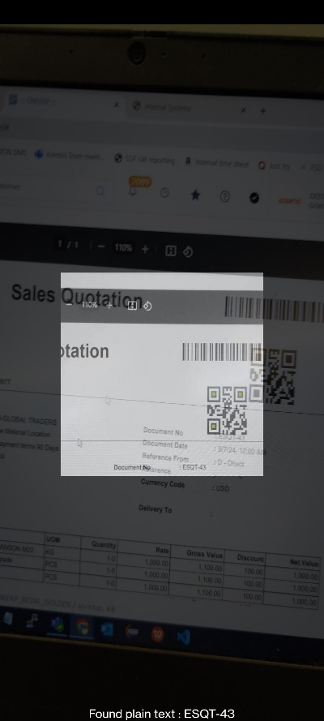
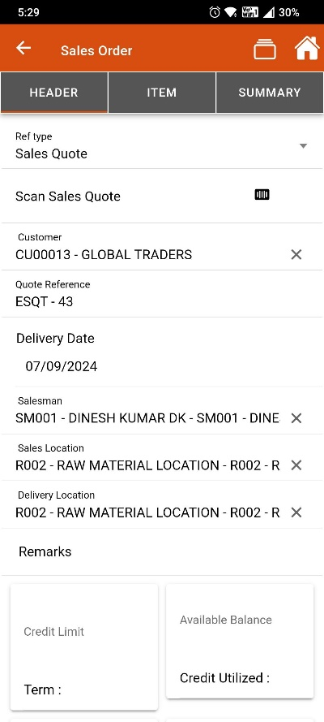
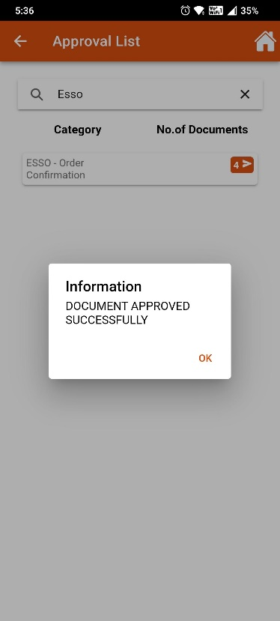

Delivery Note
A delivery note is a document accompanying a shipment, detailing the items delivered, quantities, and any relevant information, serving as proof of delivery for both the sender and recipient.
Features available as part of this are listed below.
- Can be created as Direct/with reference to Sales Order/Invoice
- Scan Sales Order/Invoice feature to fetch details in Delivery Note
- Scan Item & select Batch, Serial Item details
- LOV for selecting Customer & Item
- Document Approval/Pushback option
- Document download option

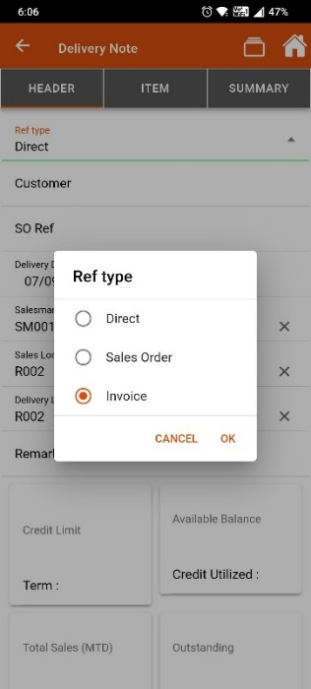
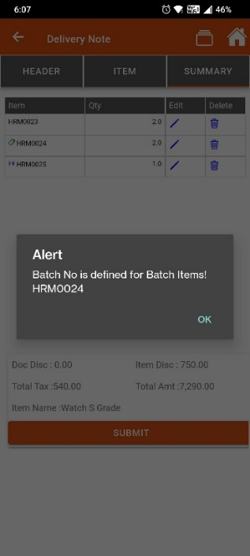
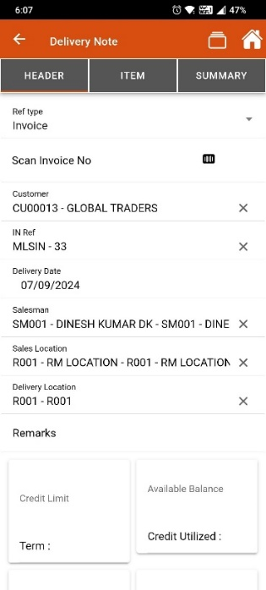

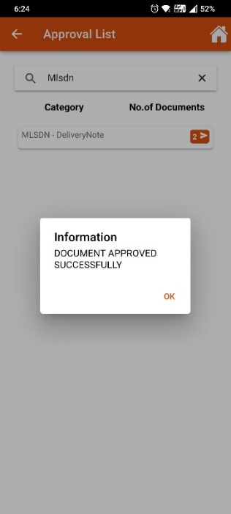

Sales Invoice
A sales invoice is a formal request for payment sent to a customer, detailing the products or services provided, their quantities, prices, and payment terms.
Features available as part of this are listed below.
- Can be created as Direct/with reference to Sales Order/Delivery Note
- Scan Sales Order/Delivery Note feature to fetch details in Sales Invoice
- Scan Item & select Batch, Serial Item details
- LOV for selecting Customer & Item
- Item line level tax & discount
- Document Approval/Pushback option
- Document download option
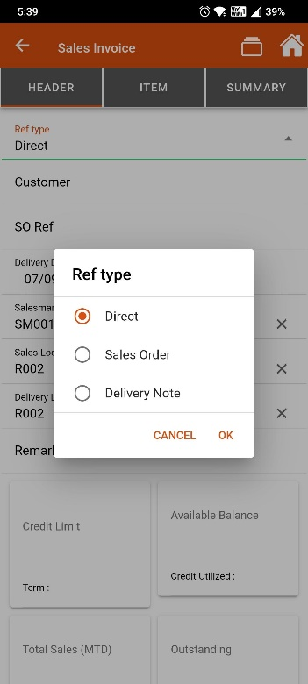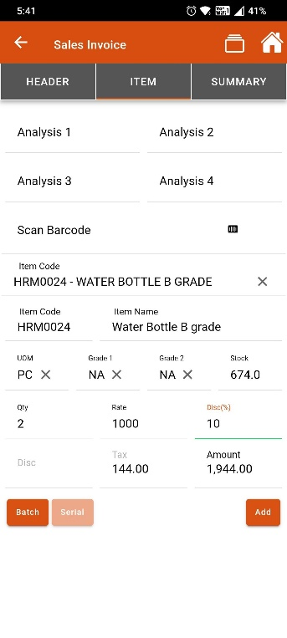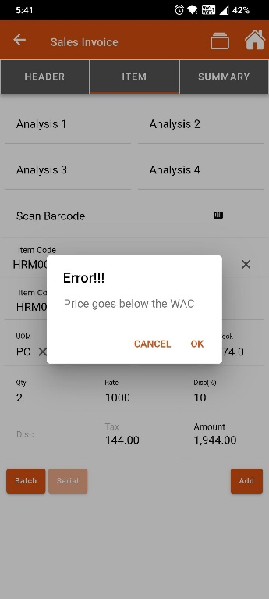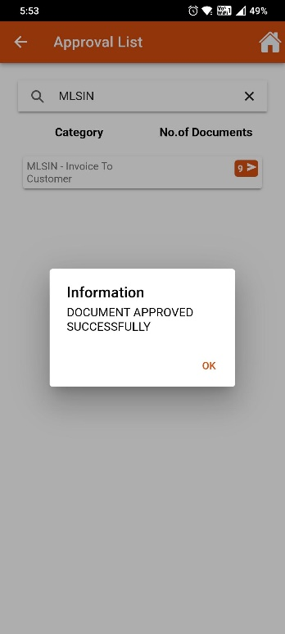

Support for KSA e-invoicing
Additional fields to support KSA e-invoicing for sales invoice transactions.
- Payment Mode
- Tax Exception Reason
- Tax Reason Code Others
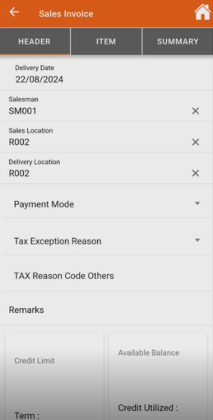

Sales Return
A sales return is a transaction in which a customer returns previously purchased goods to the seller.
Features available as part of this are listed below.
- Can be created as Direct/with reference to Sales Invoice/Delivery Note
- Scan Sales Invoice/Delivery Note feature to fetch details in Sales Invoice
- Scan Item & select Batch, Serial Item details
- LOV for selecting Customer & Item
- Item line level tax & discount
- Document Approval/Pushback option
- Document download option
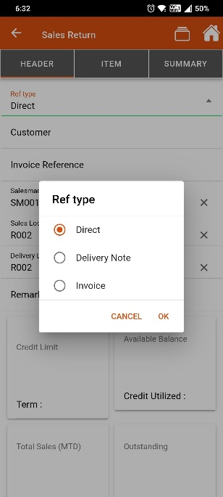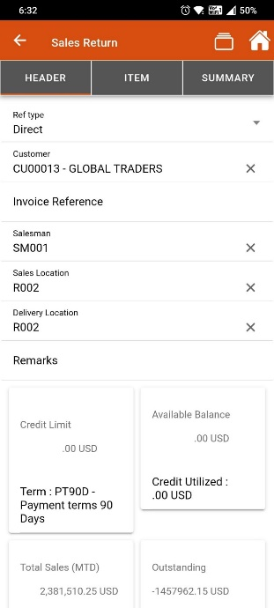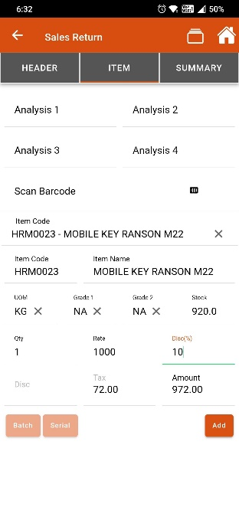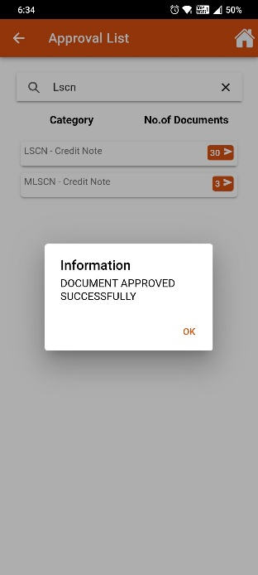

Support for KSA e-invoicing
Additional fields to support KSA e-invoicing for sales invoice transactions.
- Payment Mode
- Tax Exception Reason
- Tax Reason Code Others

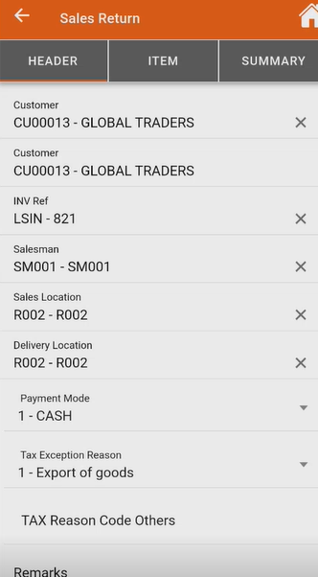

Customer Status
Provides the Customers outstanding balances for pending invoices
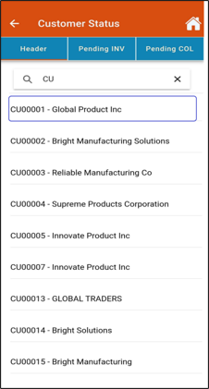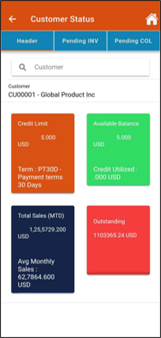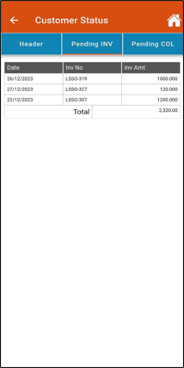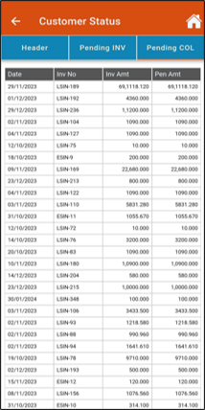

Price List Update
A pricelist is a document or database that outlines the prices of goods or services offered by a business, often including details such as product descriptions, quantities, and any applicable discounts or terms.
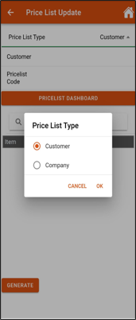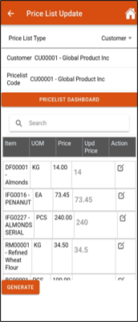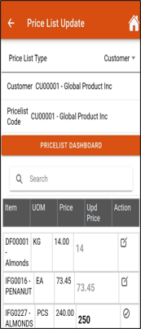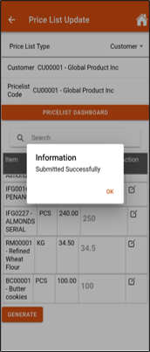

Mobility Inventory

Location Transfer Out
Location transfer out refers to the process of moving inventory or assets from one location to another, often documented to maintain accurate stock levels and track items during the transfer.
- Direct creation
- Scan Item & select Batch, Serial Item details
- LOV for selecting Location & Item
- Document Approval/Pushback option
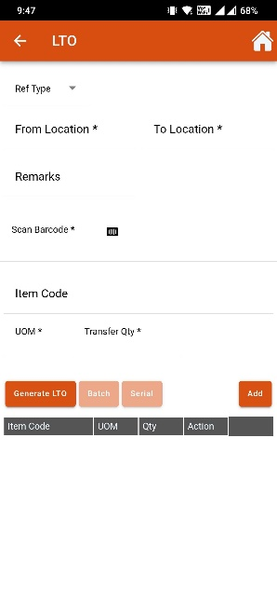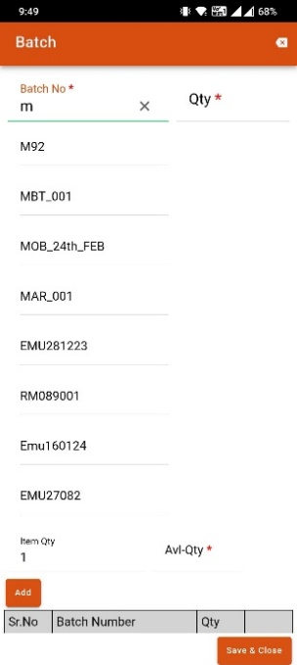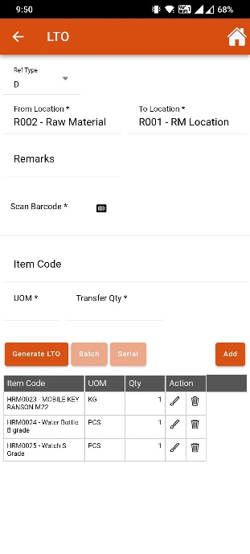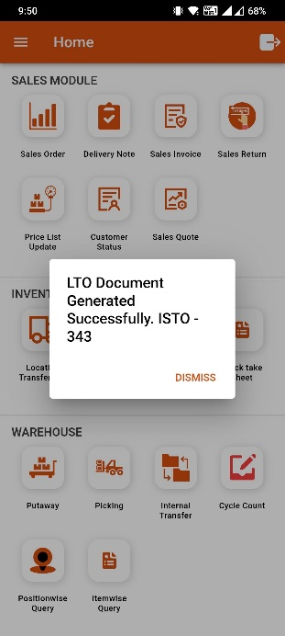

Location Transfer In
Location transfer in refers to the process of receiving inventory or assets into a specific location from another site, often documented to update stock levels and track the movement of items accurately.
- Can be created with reference to LTO
- Scan Item & select Batch, Serial Item details
- LOV for selecting Customer & Item
- Document Approval/Pushback option
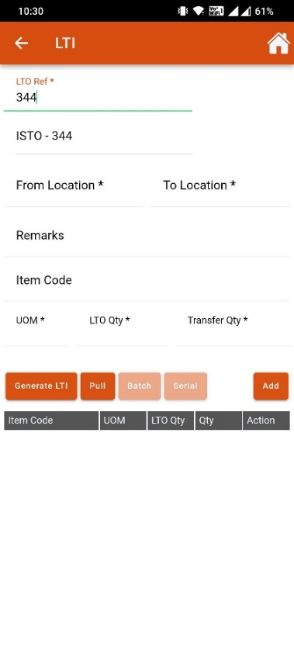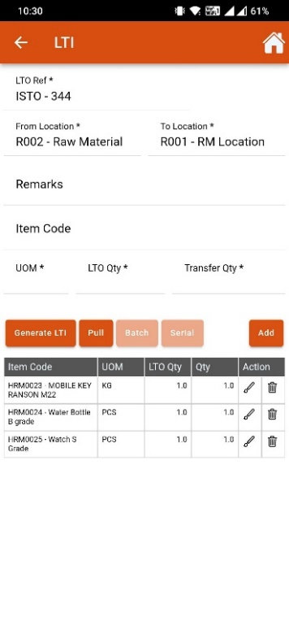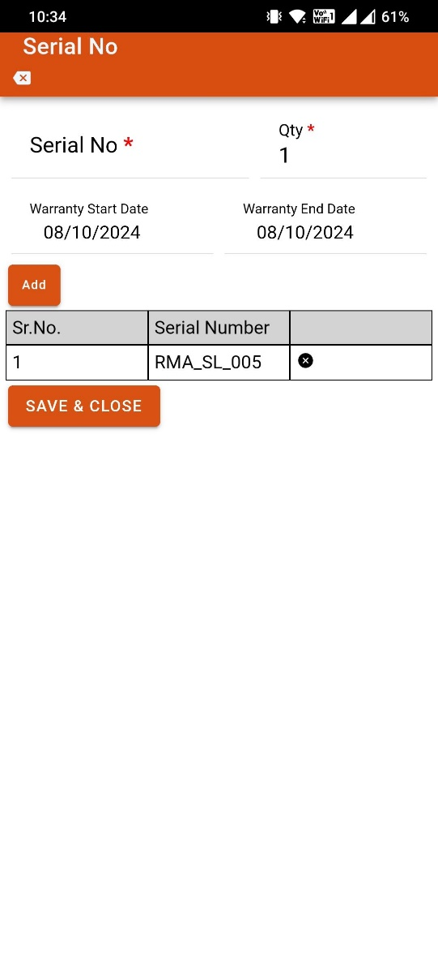

Stock Status
Location wise stock details displayed based on the input details.
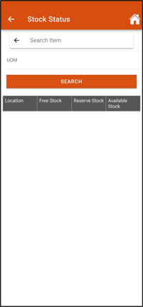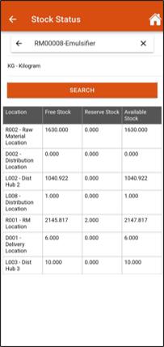

Stock Take Sheet
A stock take sheet is a document used to record the quantities and details of inventory items during a physical count, helping to ensure accurate stock levels and identify discrepancies.
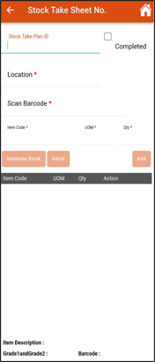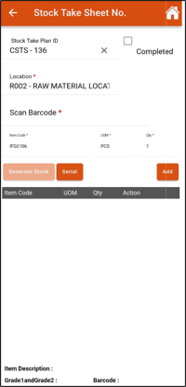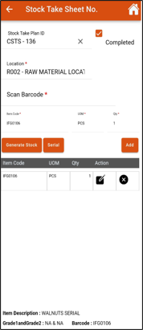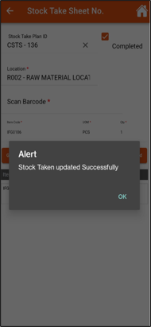

Mobility Procurement

GRN with PO
A Goods Receipt Note (GRN) is a document issued by a buyer to confirm the receipt of goods from a supplier, detailing the quantities and specifications of the items received for inventory records.
- Created with reference to PO
- Scan Item & Add Batch, Serial Item details
- Document Approval/Pushback option
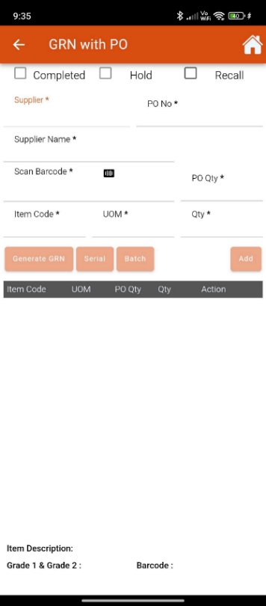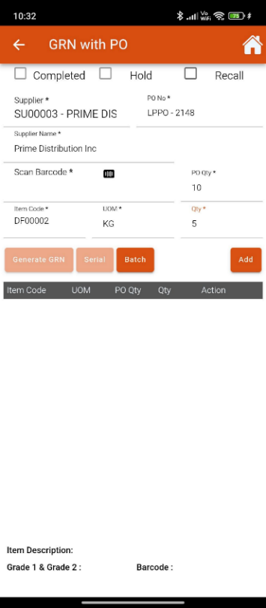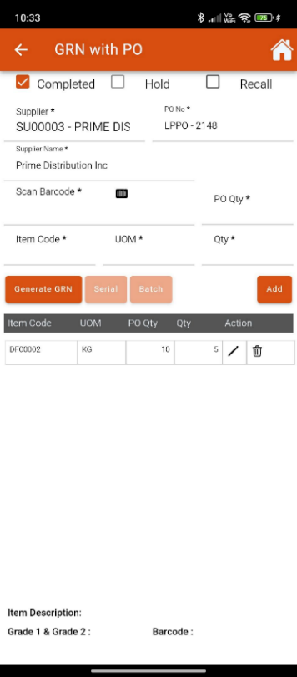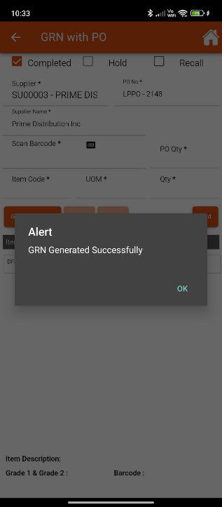

Direct GRN
A Goods Receipt Note (GRN) is a document issued by a buyer to confirm the receipt of goods from a supplier, detailing the quantities and specifications of the items received for inventory records.
- Direct GRN creation
- Scan Item & Add Batch, Serial Item details
- LOV for selecting Supplier & Item
- Document Approval/Pushback option
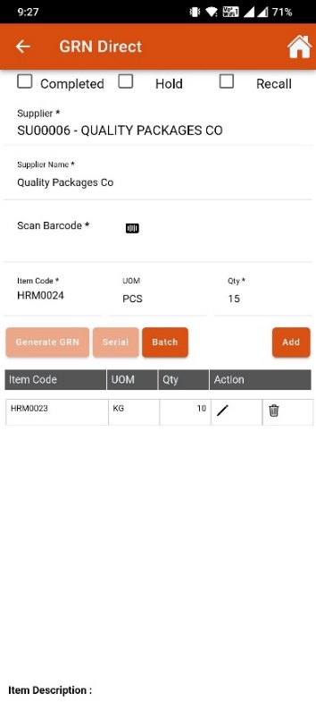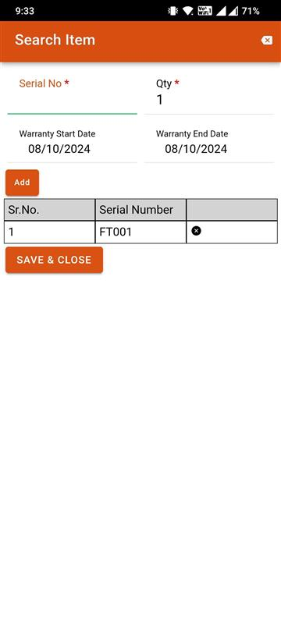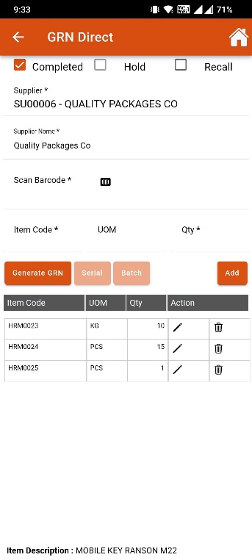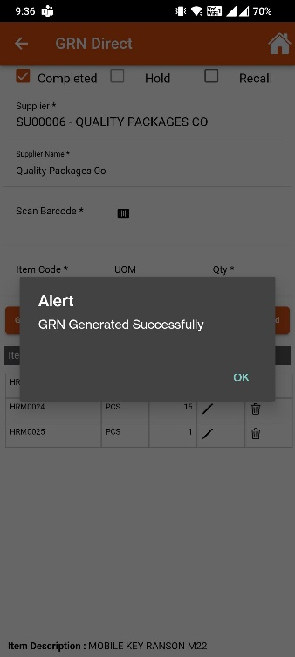

GRN Cum Costing
A GRN cum Costing document combines a Goods Receipt Note with cost details, providing not only confirmation of received goods but also the associated costs for inventory management and accounting purposes.
- Direct GRN Cum GRN Costing creation
- Scan Item & Add Batch, Serial Item details
- LOV for selecting Supplier & Item
- Item level Tax
- Document Approval/Pushback option
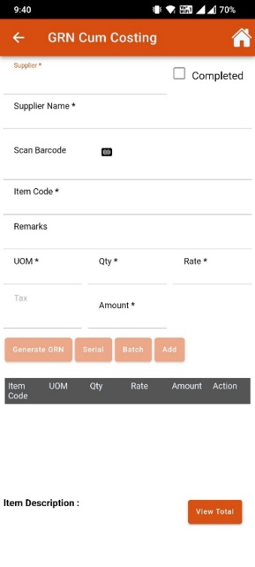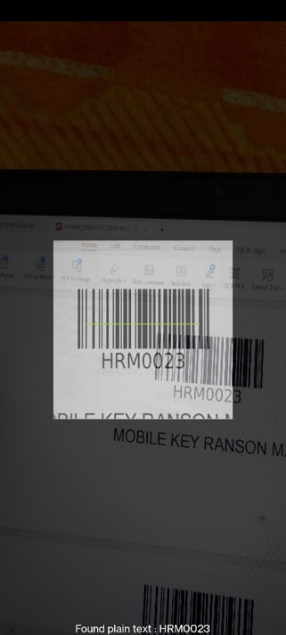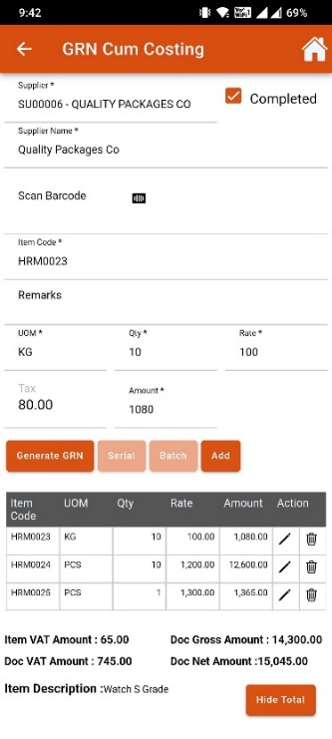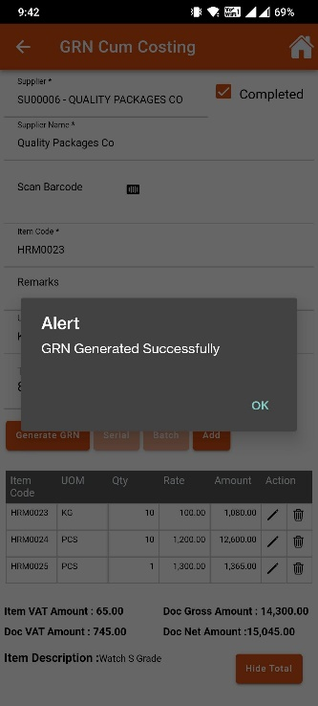

Mobility WMS

Putaway
Putaway is the process of storing received inventory in designated locations within a warehouse or storage area, ensuring items are organized for efficient retrieval and management.
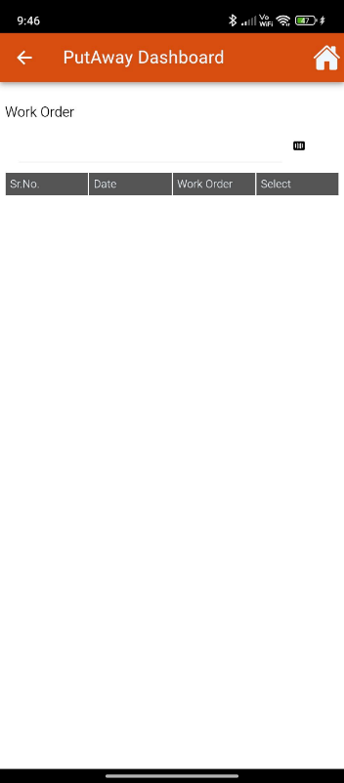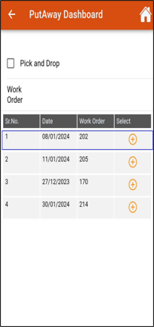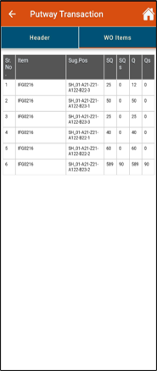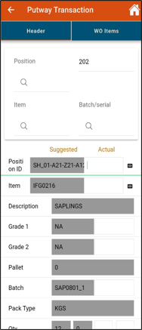
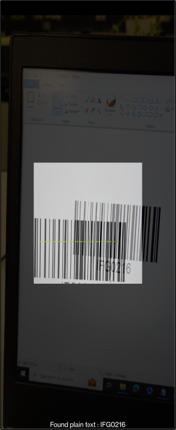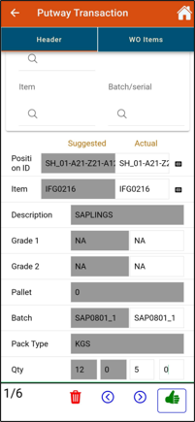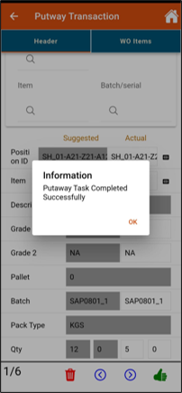

Picking
Picking is the process of selecting and gathering items from inventory in a warehouse or storage area to fulfill a customer order, often involving specific techniques to maximize efficiency and accuracy.
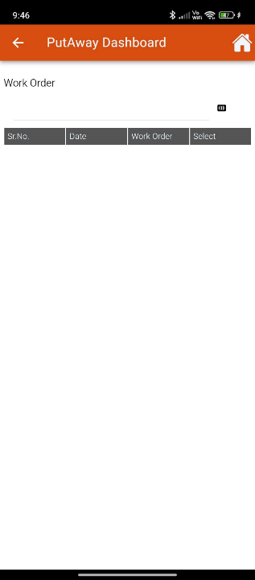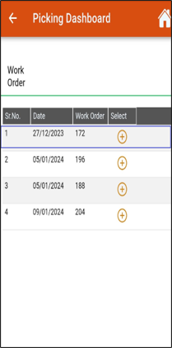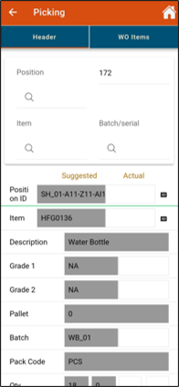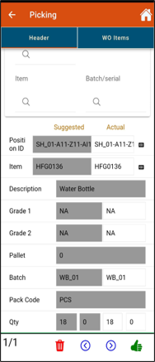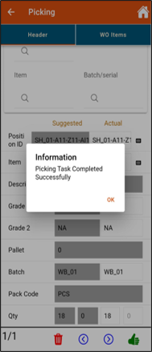

Internal Transfer
Internal transfer refers to the movement of inventory or assets between different locations or departments within the same organization, aimed at optimizing stock levels and resource allocation.
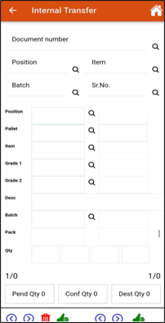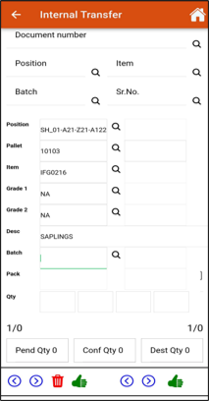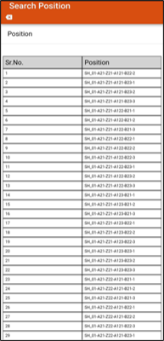
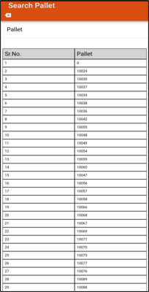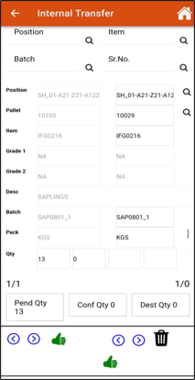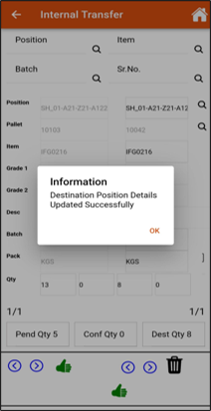

Cycle Count
A cycle count is a periodic inventory audit method where a subset of inventory is counted on a scheduled basis to ensure accuracy in stock levels, rather than conducting a full physical inventory.
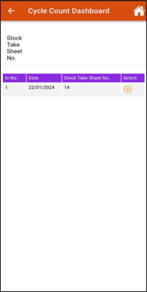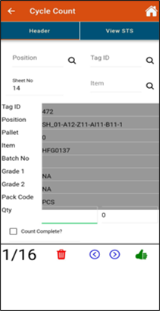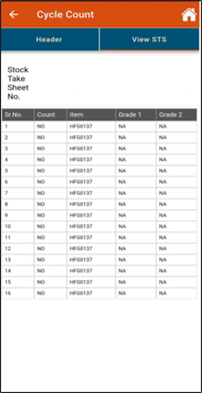

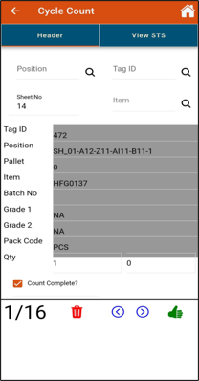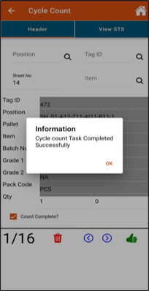

Positionwise Query
A positionwise query retrieves data based on specific locations or positions within a system, often used to analyze inventory or asset distribution by location.
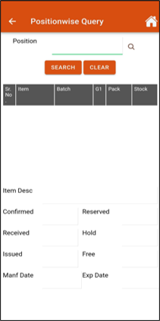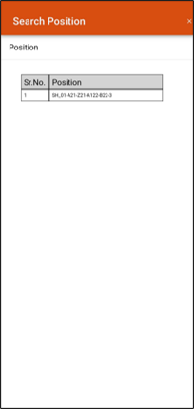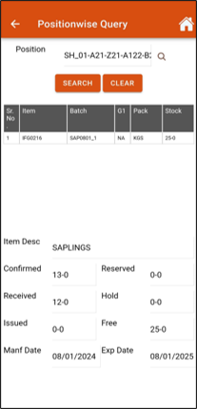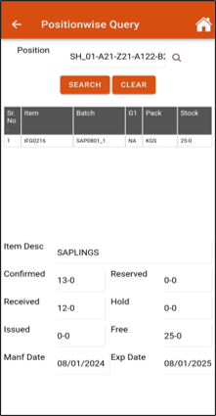

Itemwise Query
An itemwise query focuses on individual items, extracting information related to specific products or assets, such as stock levels.
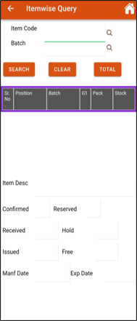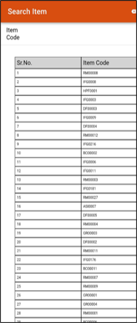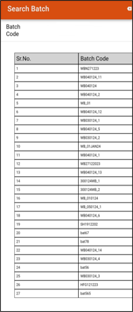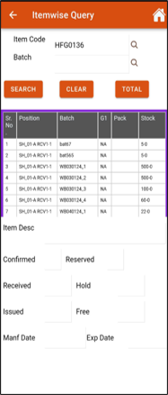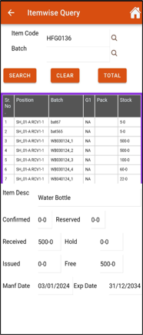

Configurations to be considered
- Reservation / Over reservation feature is not handled in mobility solutions
- Transaction / Document getting approved from mobility solutions will get directly approved and FEG posting will happen as applicable
- This will not consider the following configurator / parameters available at transaction level
  - Document Flow > Posting after confirmation - Yes/No (If stock posting after Confirmation is required then Yes parameter can be selected, if not required select No)
  - Inventory> Confirmation after approval - Yes/No (If confirmation after approval is required then the parameter can be set as Yes, if not required it can be No)
  - Finance> GL Posting required - Yes/No (If GL/Financial Posting is required then the parameter can be set as Yes, if not required it can be No)

About Azentio Software
Azentio provides core software to BFSI clients and mid-market ERP systems across the Middle East, Africa, and Asia Pacific. The company is committed to partner with its clients globally to transform their business operations through continuous focus on innovation and best-in-class customer service. Azentio has over 1,000 clients in more than 65 countries.
Headquartered in Singapore, the company has offices in 9 countries with a skilled and talented workforce of over 2,000 employees. Azentio Software Private Limited is wholly owned by funds advised by Apax Partners: www.azentio.com

Head Office
38 Beach Road, #29-11 South Beach Tower, Singapore 189767

